Bahria University,

Karachi Campus



LAB EXPERIMENT NO.

**8**

LIST OF TASKS

|  |  |
| --- | --- |
| TASK NO | OBJECTIVE |
| **1** | **Write a Python program to determine the area enclosed by the function f(x) = e x over the interval from x=0 to x=2 using the Trapezoidal Rule with two intervals. (Output: 6.9128)** |
| **2** | **Write a Python program utilizing Simpson's 1/3 Rule to compute the definite integral where n = 4 represents the number of intervals used in the approximation. (Output: 17.6322)** |
| 3 | Determine the approximation of the area beneath the curve represented by y = f(x) over the interval from x=−4 to x=2 using the Trapezoidal Rule with n=6 subintervals. The values of the function f(x) are provided within following table |

Submitted On:

**Date: 30/11/2023**

**Task No. 01:**

**Write a Python program to determine the area enclosed by the function f(x) = exp(x) over the interval from x=0 to x=2 using the Trapezoidal Rule with two intervals.**

**(Output: 6.9128)**

**Solution:**

import math

def function(x):

return math.exp(x)

def trapeziodal_rule(a,b,n):

h=(b-a)/n

result= function(a)+function(b)

i=1

while i<n:

result+=2*function(a+i*h)

i+=1

return result*(h/2)

a=0

b=2

n=2

print('area under the curve : ',trapeziodal_rule(a,b,n))

**Output:**

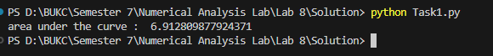

**Task No. 02:**

**Write a Python program utilizing Simpson's 1/3 Rule to compute the definite integral** **where n = 4 represents the number of intervals used in the approximation. (Output: 17.6322)**

**Solution:**

import math

def function(x):

return math.log(x)

def simpson_rule(a,b,n):

h=(b-a)/n

x_values=[]

f_x_values=[]

i=0

while i<n:

x_values.append(a+i*h)

f_x_values.append(function(x_values[i]))

i+=1

result=0

i=0

while i<n:

if i==a or i==b:

result+=f_x_values[i]

elif i%2==0:

result+=2*f_x_values[i]

else:

result+=4*f_x_values[i]

i+=1

return result*(h/3)

a=math.exp(2)

b=2*math.exp(2)

n=4

print('area under curve: ',simpson_rule(a,b,n))

**Output:**

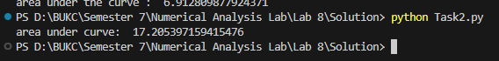

**Task No. 03:**

**Determine the approximation of the area beneath the curve represented by y = f(x) over the interval from x=−4 to x=2 using the Trapezoidal Rule with n=6 subintervals. The values of the function f(x) are provided within following table:**

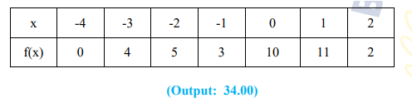

**Solution:**

def trapezoidal_rule_from_points(points):

n = len(points)

integral = points[0][1] + points[-1][1]

for i in range(1, n - 1):

integral += 2 * points[i][1]

h = points[1][0] - points[0][0]

integral *= h / 2

return integral

given_points = [(-4, 0), (-3, 4), (-2, 5), (-1, 3), (0, 10),(1,11),(2,2)]

result = trapezoidal_rule_from_points(given_points)

print("Approximated integral value using given points:", result)

**Output:**

